
Driven Mad

By Tyson Shannon, Simon Seyoum, Nathan Langenfeld, Barry Theirno
Table of Contents
Game Plot 3
Controls 3
Levels 4
Level 1: The Basic Car 4
Level 2: The Muscle Car 4
Level 3: The Van 5
Level 4: The Truck 5
Gameplay 6
Health & Damage 6
Powerups 7
Weapons 7
Zombies 8
Spawning 8
Season & Time Cycle 8
Death 9
High Scores 9

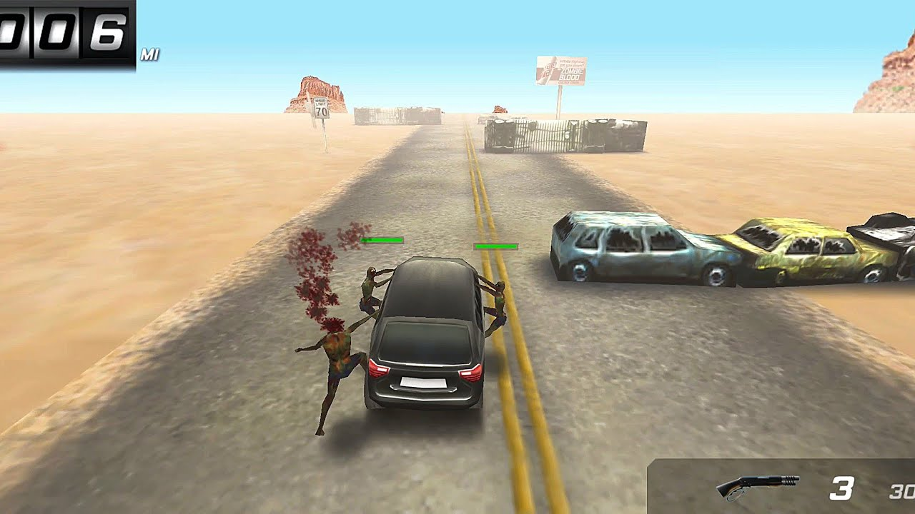

Game Plot
Civilization has fallen and you’re one of the final inhabitants uninfected. To survive you must get as far as you can on one of the last vehicles still capable of traversing the zombie filled roads. In the distance, the promise of a zombie free barricaded city. The remnants of society, from broken down cars to lost weapons, will be your lifeline as you make one last race to safety.

Controls
The car will automatically move faster and faster as the player travels. The player will be able to move the car left and right with the A and D keys. Zombies will be automatically shot if bullets are available and a gun is equipped but can also be killed by driving close to obstacles.
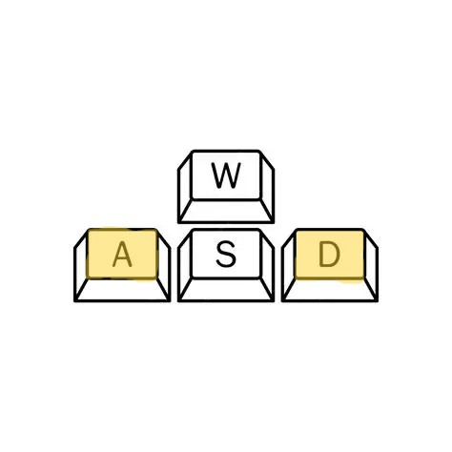

Levels

Level 1: The Basic Car
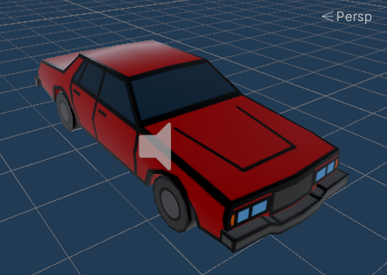
The basic car provides an average level of difficulty with middle of the road speeds and easy handling. Only one zombie can jump on either side, and it has 100 health points making survival more likely.

Level 2: The Muscle Car
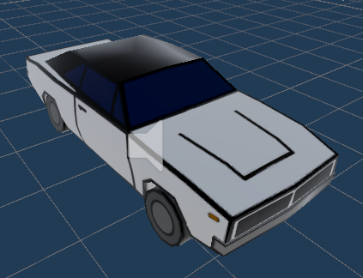
The muscle car is for survivors who still have something to compensate for. It starts at far faster speeds but requires more skill to maneuver without crashing. Two zombies can grasp each side, and it has 75 health points making it a speedy target for the undead.

Level 3: The Van
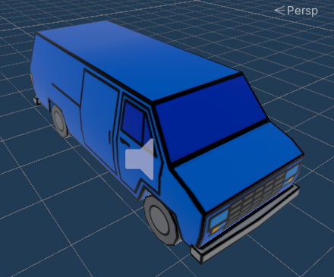
The van is a last resort for any survivor but can still get you to your destination. As a slower vehicle zombies are less likely to miss jumping on to you, however it is fairly easy to handle at higher speeds. Three zombies can jump on each side, and it only has 50 health points making you a sitting duck.

Level 4: The Truck
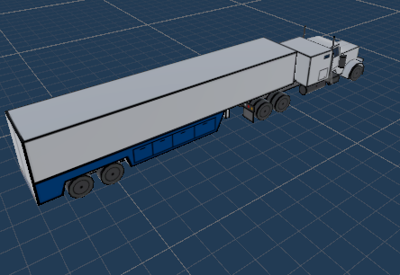
Amazon stops for no plague and it’s your responsibility to deliver all those packages. The truck is incredibly slow to start and very hard to maneuver making your death almost guaranteed. As a result of the long trailer five zombies can fit on each side, however you are a little more protected with 150 health points.

Gameplay
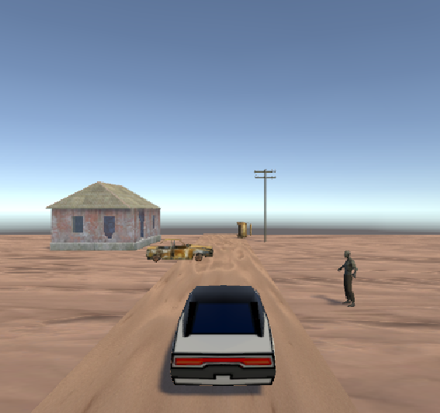
This is an infinite driving game where the player see’s how far they can drive across 4 different car types/levels. As the player gets further the car speeds up increasing the difficulty.

Health & Damage
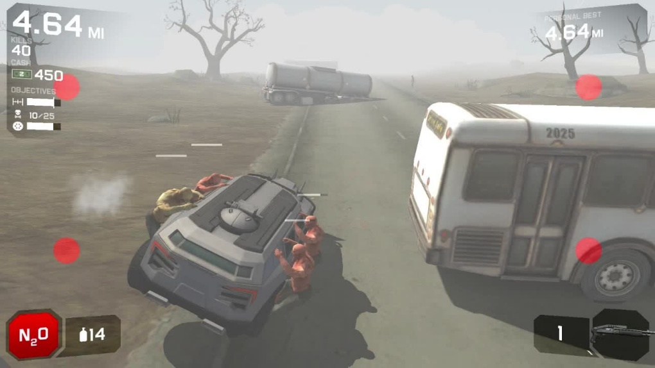
Gas is your cars health. A health bar at the top of the screen and will go down as zombies bang on your car. You can pick up gas as you drive to refill your meter. Each car has a different amount of health depending on level difficulty.

Powerups
There are numerous positive and negative temporary powerups left on the side of the road for you to pick up including:
- Instant kill- Allows you to one shot zombies
- Zombie distraction- Makes zombies run away from your car
- Zombie Speed- Makes zombies faster and more likely to grab your car
- NOS- Car speed up in exchange for maneuverability
- Train Plow- Can ram into zombies without taking damage

Weapons
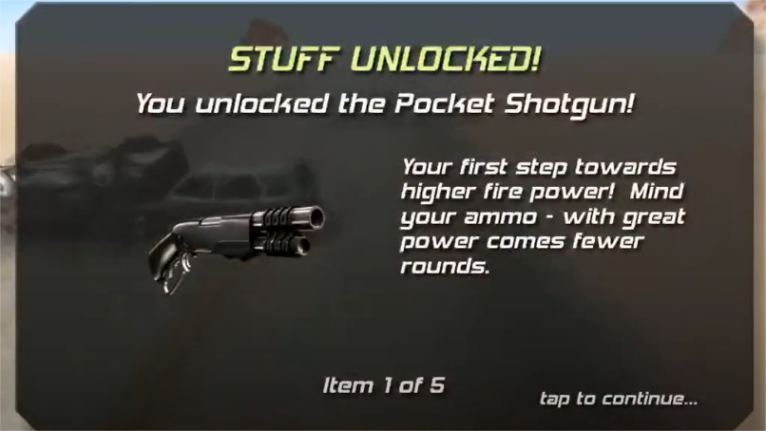
Weapons have also been left on the side of the road and can include:
- Pistol- 30 ammo, 10 damage, medium attack speed
- Shotgun- 10 ammo, 25 damage, slow attack speed
- Machine Gun- 100 ammo, 20 damage, fast attack speed
- Chainsaw – 15 seconds, 100 damage, slow attack speed
Weapons will automatically target the highest health enemy if ammo is available. Grabbing multiple of the same weapon will increase your ammunition. You can also kill zombies by driving close to obstacles and knocking them off.

Zombies
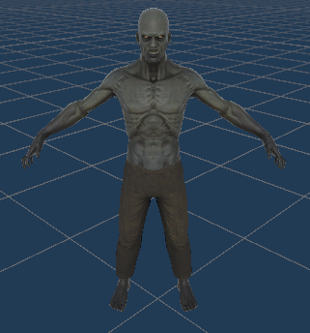
Regular Zombies: These zombies spawn on regular intervals and will jump on your vehicle to deal it damage. They can be killed with both weapons and obstacles. They have 100 health points.
Boss Zombies: These zombies will spawn every 120 seconds +- 60 seconds. They will jump on top of your car and must be killed with weapons. They have 200 health points.

Spawning
Zombies will spawn every 20 seconds left or right of the car as long as there is still space on the vehicle. Boss zombies will spawn every 120 seconds plus or minus 60 seconds for RNG. Obstacles and terrain details will also spawn randomly during gameplay.

Season & Time Cycle
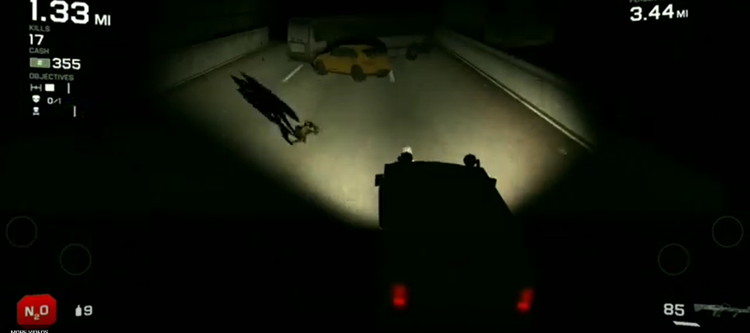
The time and season cycles will have impacts on the gameplay. They have durations of 3 minutes each and are random. After each season player returns to daytime for 3 minutes. The cycles include:
- Daytime- Default, no effects
- Nighttime- More zombies spawn more often
- Winter- Makes driving more difficult as road gets slippery
- Fall- Fog makes it hard to see
- Red Moon- Zombies do more damage

Death
If your car reaches 0 gas/health from zombie damage the car stops and zombies kill you. If you run into an obstacle your car crashes and you die. You can also die by having too many zombies on one side causing you to tip over if you take too hard of a turn.

High Scores
Each time you die the distance traveled is recorded, if you beat the previous longest distance for that level the high score is recorded. Each level has a unique high score variable.

Initial Assignments:
- Spawning of obstacles and objectives and zombies – Nathan
- Road movement and car controls and handling– Tyson
- Zombie damage and car holding – Simon
- Death animations and high score and health system - Barry

